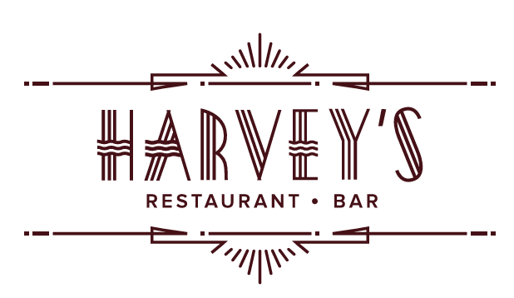

SUNDAY BRUNCH

Freshly Baked French Baguette  6
House Cultivated Honey Whipped Butter

COOL & CRISP

Buffalo Devilled Eggs  12
Smoke, Sriracha, Blue Cheese Powder

Panko Crusted Goat Cheese Salad 16
Roasted Beets, Cranberries, Hazelnut Vinaigrette

The Henderson Caprese 14
Bocconcini, Tomatoes, Herb Oil,
Strawberry-Balsamic Reduction

Ahi Tuna Tartare  18*
Smashed Avocado, Yuzu, Soy, Baked Wonton Crisps

Scottish Smoked Salmon Roulade 16
Cream Cheese, Everything Bagel Chips,
House Cultivated Hot Honey

Gluten FreeLactose Free
 Pescatarian Vegetarian  Vegan
GFO Gluten Free Available
- 0A Vegetarian Option Available

SMALL PLATES

French Onion Soup 10
Brioche Crouton, Gruyère Cheese

Fried Duck Dumplings 12
Mango-Habanero Jelly

Escargots à la Bourguignonne 14
Garlic-Parsley Butter, Toast Points

Baked Brie en Croûte 14
Raspberry- Jalapeño Preserves,
French Bread Crostini’s

Bacon Wrapped Medjool Dates 14
Feta, Red Pepper-Bacon Marmalade

LUNCHY THINGS

Traditional British Fish & Chips  22
Beer Battered Cod, Twice Cooked Russet Potatoes, Homemade Tartar Sauce

Pan Seared NC Mountain Trout 22
Summer Leaves, Lemon-Pepper Vinaigrette

Hoisin BBQ Baby Back Ribs24
Soba Noodles & Asian Slaw, Tahini Dressing,
Scallions, Sesame Seeds

Free Range Chicken Pot Pie 24
Baby New Potatoes, Peas, Carrots, Thyme,
Short Crust Pastry

Zucchini ‘Ravioli’ 20
Ricotta, Spinach, Basil, Mozzarella Cheese,
Fresh Tomato Sauce
BRUNCHY THINGS

Fried Green Tomatoes Benedict 18
Poached Eggs, Potato Hash, Fresh Fruit, Chipotle Hollandaise *

Country Ham & Cheddar Omelet  14
Potato Hash, Fresh Fruit

Brioche French Toast 14
Wild Berry Maple Syrup, House Cured Bacon 0A

Buttermilk Blueberry Pancakes 14
House Cured Bacon, Wild Berry Maple Syrup 0A

Smashed Avocado Toast 16
Scrambled Eggs, Homemade Tomato Jam,
Fresh Fruit, Potato Hash GFO

Cajun Breakfast Burrito 16
Scrambled Eggs, Andouille Sausage, Peppers, Cheese, Sour Cream, Salsa

Caprese Frittata 18
Buffalo Mozzarella, Teardrop Tomatoes, Basil,
Fresh Fruit, Potato Hash

*Consuming raw or undercooked meats, poultry, seafood, shellfish, or eggs may increase your risk of foodborne illness

