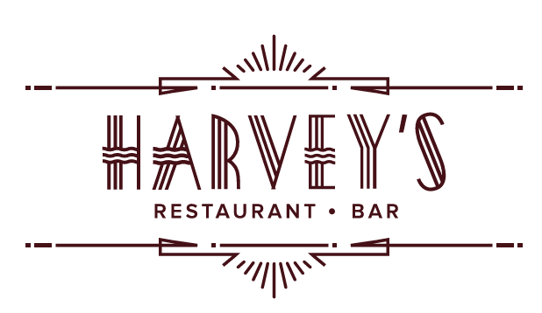
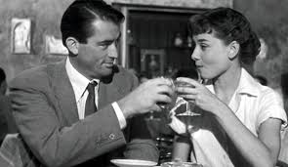
LIQUID LIBATIONS

“Fill your life with friends and your glass with wine”

COCKTAILERY & TOM FOOLERY 12

Red Appletini |Jim Beam, Red Apple Liqueur, Cranberry Juice, & Lemon Juice

Harvey’s Martini | NC Conniption Gin,
Dry Vermouth, Caper Berries

Myrtle Mae |Tito’s Vodka, Cointreau, Pomegranate Juice, Fresh Lemon & Lime

Gin Rickey |Beefeater Gin, Fresh Lime Juice,
Soda Water

Nutty Irishman |Stoli Vanilla, Frangelico,
Irish Cream, Nutmeg

Negroni |Campari, NC Conniption Gin,
Sweet Vermouth

Hemingway Daiquiri |Bacardi Rum, Luxardo,
Fresh Grapefruit Juice

Paloma | Tequila, Amaro Liqueur,
Fresh Lime & Grapefruit Juices

Classic Cosmopolitan |Absolut Citron, Cointreau, Cranberry Juice, Fresh Lime

Manhattan |Bulleit Rye, Sweet Vermouth, Angostura Bitters

Old Fashioned |Bourbon, Angostura Bitters, Orange & Amarena Cherry Mash

“I drink to make other people more interesting.” — Ernest Hemingway
MOCKTAILS & DREAMS 12

Zero Fashioned |NA Bourbon, Bitters,
Orange & Amarena Cherry Mash

Tommy Collins | NA Gin, Fresh Lemon Juice,
Homemade Syrup, Soda Water

Traditional Daiquiri | Fleur NA Rum, Orange Simple Syrup, Fresh Lime Juice

Pom Margarita | NA Tequila, NA Triple Sec, Pom, Fresh Lime Juice

Alfie |NA Gin, Triple Sec, Fresh Lemon,
Homemade Syrup

BARLEY & BREWS 6
Sierra Nevada Pale Ale
Hazy Little Thing IPA
Dash City Lager
Foothills Torch Pilsner
Sam Adams – ‘Just the Haze’ IPA (Alcohol Free)
Bero – Pilsner (Alcohol Free)
Bero– IPA (Alcohol Free)

BUBBLES
Tribaut| Champagne, France 375ml 30
Col Solivo |Prosecco, Italy 10/ 36
Freixenet NA | Brut Cava, Spain 10/ 36
(Alcohol Free)

BOTTLE SPECIALS 30
Markstone, Cabernet, 2022| California
Benzinger, Chardonnay, 2022 | California
Markstone, Chardonnay, 2022 | California
Avia, Pinot Grigio, 2022 | Slovenia

, Cabernet, 2021 | Paso Robles 35

WHITES

Villa Brici, Pinot Grigio 2023| Slovenia 10/ 35
Kendall Jackson, Vintner’s Reserve, Chardonnay, 2023 | California 12/ 36
Matua, Sauvignon Blanc, 2022 | Marlborough,
New Zealand 12/ 36
Sean Minor, Sauvignon Blanc, 2022 | CA, 12/ 36
Sokol Blosser, Evolution # 9, White Blend 2021 |Oregon 12/ 36
Cordillera Reserva, Chardonnay, 2022 | Chile 40
Menade Verdejo Organic, 2023 | Spain 40
Marola, Albarino, 2023 | Spain 45
Giesen, Sauvignon Blanc | New Zealand 10/35 (Alcohol Free)

ROSE

Sean Minor |California, 2024 12/ 36

REDS

Coppola, Cabernet, 2021|Paso Robles 12/ 36
Coppola, Pinot Noir, 2021| Monterey 12/ 36
Geisen, Red Blend | New Zealand 35 (Alcohol Free)
Lan, Tempranillo, 2021| Rioja, Spain 45
Escudo Rojo, Syrah Gran Reserve, 2022| Chile 45
Heritage, Pinot Noir, 2021| Willamette Valley 50
Lady Hill, Pinot Noir, 2021| Willamette Valley 50
Educated Guess, Cabernet, 2021 | CA 50
WINE OF THE MONTH
‘CUVEE NOKAT’
Sauvignon Blanc, 2024
Bordeaux 35

