DESSERTS
SWEET & SINFUL 12

Honey & Fig Panna Cotta
Vanilla Crème

Molten Valrhona Chocolate Cake
Cookies & Cream Ice Cream

Raspberry Crème Brûlée 
Caramelized Sugar

Key Lime Pie Cheesecake
Fresh Strawberries



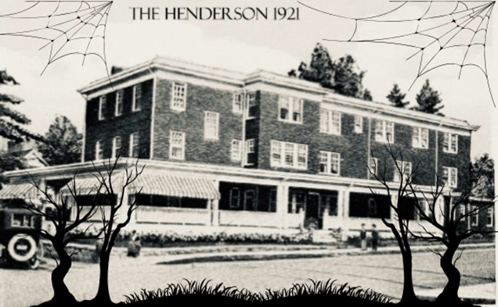

HALLOWEEN HAUNTED HOTELS OF AMERICA WINE DINNER
FRIDAY OCTOBER 31ST 2025

The Hawthorne Hotel, Salem, MA
NEW ENGLAND CLAM CHOWDER
Quahog Clams, Potatoes, Cream, Crackers
Michael David Winery, Freakshow Chardonnay Lodi

The Henderson, Hendersonville NC
PANKO CRUSTED GOAT CHEESE SALAD
Roasted Beets, Cranberries, Toasted Hazelnut Vinaigrette
19 Crimes, The Bride of Frankenstein, Red Blend, Australia

Hotel Monteleone, New Orleans, LA
BLACKENED SALMON JAMBALAYA
Jasmine Rice, Vegetables, Creole Seasoning
19 Crimes, Cabernet Sauvignon, Frankenstein, Australia

The Stanley Hotel, Estes Park, CO
PUMPKIN SPICE PANNA COTTA
Ginger Snap Cookie
Michael David Winery, Freakshow Zinfandel Lodi

Dinner $100 per person including tax & gratuity
Dinner & Wine Pairing $135 per person including tax & gratuity
Call (828) 696-2001 or email info@thehendersonnc.com
for reservations

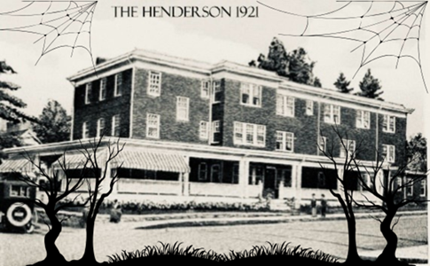

HALLOWEEN HAUNTED HOTELS OF AMERICA WINE DINNER
FRIDAY OCTOBER 31ST 2025

The Hawthorne Hotel, Salem, MA
NEW ENGLAND CLAM CHOWDER
Quahog Clams, Potatoes, Cream, Crackers
Michael David Winery, Freakshow Chardonnay Lodi

The Henderson, Hendersonville NC
PANKO CRUSTED GOAT CHEESE SALAD
Roasted Beets, Cranberries, Toasted Hazelnut Vinaigrette
19 Crimes, The Bride of Frankenstein, Red Blend, Australia

Hotel Monteleone, New Orleans, LA
BLACKENED SALMON JAMBALAYA
Jasmine Rice, Vegetables, Creole Seasoning
19 Crimes, Cabernet Sauvignon, Frankenstein, Australia

The Stanley Hotel, Estes Park, CO
PUMPKIN SPICE PANNA COTTA
Ginger Snap Cookie
Michael David Winery, Freakshow Zinfandel Lodi

Dinner $100 per person including tax & gratuity
Dinner & Wine Pairing $135 per person including tax & gratuity
Call (828) 696-2001 or email info@thehendersonnc.com
for reservations
DESSERTS
SWEET & SINFUL 12

Honey & Fig Panna Cotta
Vanilla Crème

Molten Valrhona Chocolate Cake
Cookies & Cream Ice Cream

Raspberry Crème Brûlée
Caramelized Sugar

Key Lime Pie Cheesecake
Fresh Strawberries

