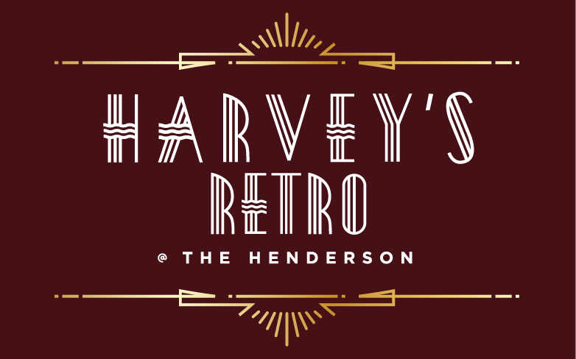



MOTHER’S DAY SUNDAY BRUNCH

**APPETIZERS**

***(Choose One)***

**French Onion Soup**

Brioche Crouton, Gruyère Cheese

**Escargots à la Bourguignonne**

Garlic-Parsley Butter, Toast Points

**Fried Louisiana Oysters** 

Baby Greens, Lemon Aioli

**Traditional Caesar Salad** 

Romaine, Shaved Parmesan, Caesar Dressing, Croutons

**The Henderson Caprese** 

Bocconcini, Tomatoes, Herb Oil,

Strawberry-Balsamic Reduction

**Jumbo Shrimp Cocktail** 

Lemon-Tomato-Horseradish Sauce, Wakame Salad

 Gluten FreeLactose Free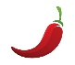 Spicy

 Pescatarian Vegetarian

***\*Consuming raw or undercooked meats, poultry, seafood, shellfish, or eggs may increase your risk of foodborne illness***

**LUNCHY & BRUNCHY THINGS**

***(Choose One)***

**Smoked Salmon Benedict **

Poached Eggs, English Muffin,

Citrus Hollandaise *

**Country Ham & Cheddar Cheese Omelet **

Potato Hash, Fresh Fruit

**Brioche French Toast**

Wild Berry Maple Syrup, House Cured Bacon

**Buttermilk Blueberry Pancakes**

House Cured Bacon, Wild Berry Maple Syrup 

**Smashed Avocado Toast **

Scrambled Eggs, Chipotle Aioli, Fresh Fruit, Potato Hash

**Cajun Breakfast Burrito**

Scrambled Eggs, Andouille Sausage, Peppers, Cheese, Sour Cream, Salsa

**Caprese Frittata  **

Buffalo Mozzarella, Teardrop Tomatoes, Basil,

Fresh Fruit, Potato Hash

**Traditional British Fish & Chips **

Beer Battered Cod, Twice Cooked Russet Potatoes, Homemade Tartar Sauce

**Free Range Chicken Pot Pie** 

Baby New Potatoes, Peas, Carrots, Pastry

**Zucchini ‘Ravioli’**  

Ricotta, Spinach, Basil, Mozzarella Cheese,

Fresh Tomato Sauce

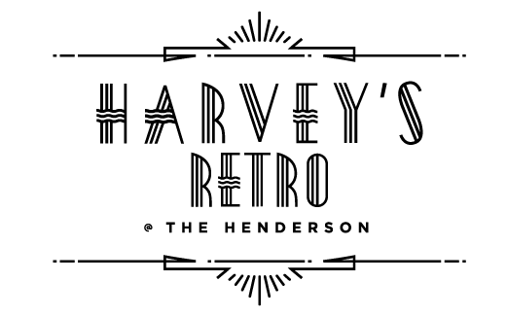

**DESSERTS**

**(Choose One)**

**SWEET & SINFUL** **12**

**

Caramelized Sugar

**Carrot Cake**

Cream Cheese Frosting

**Tiramisu**

Lady Fingers, Mascarpone, Espresso, Kahlúa

**Chocolate Brownie**

Vanilla Ice Cream

**$49 per person (plus tax & gratuity)**

